A Mini Project on

# ONLINE STUDENT ADMISSION SYSTEM

**BACHELOR OF TECHNOLOGY**

**IN**

**INFORMATION TECHNOLOGY**

*Submitted by*

**Batch No: 6**

**G N POOJA 16121A1222**

**J BHAVANA 16121A1238**

**B ABHISHEK 16121A1201**

*Under the Supervision of*

**G UMA MAHESH**

Assistant Professor Department of InformationTechnology



Department of Information Technology

# SREE VIDYANIKETHAN ENGINEERING COLLEGE

(AUTONOMOUS)

(Affiliated to JNTUA, Ananthapuramu, Approved by AICTE, Accredited by NBA & NAAC) Sree Sainath Nagar, Tirupati – 517 102, A.P., INDIA

# 2018 -2019

Department of Information Technology

**SREE VIDYANIKETHAN ENGINEERING COLLEGE**

**(AUTONOMOUS)**

(Affiliated to JNTUA, Anantapur, Approved by AICTE, Accredited by NBA & NAAC) Sree Sainath Nagar, Tirupati – 517 102, A.P., INDIA



*Certificate*

This is to certify that Mini Project entitled

**“ONLINE STUDENT ADMISSION SYSTEM”**

is the bonafide work done by

G N POOJA 16121A1222

J BHAVANA 16121A1238

B ABHSHEK 16121A1201

in the Department of **Information Technology**, **Sree Vidyanikethan Engineering College, (Autonomous), Sree Sainath Nagar, Tirupati** for Web Technologies Lab of III B.Tech I Semester during the academic year 2018-2019

Supervisor:

**G UMA MAHESH**

Assistant Professor

Dept. of Information Technology

Sree Vidyanikethan Engineering College

Sree Sainath Nagar,Tirupathi-517102

**ONLINE STUDENT ADMISSION SYSTEM**

**ABSTRACT**

Now a days the necessity of executing things are increasing rapidly in our daily activities. Technology plays a vital role in day-to-day activities. And this in turn made great changes in many work fields and out of them recruitment process is one that changed lot of colors in their systematic approaches. One of the computer based recruitment system is recruitment of students to a college.

**Online Student Admission** is a web based application that give students the opportunity to go online and apply for admission well as process their school admission details. The manual method of applying and processing students admission is very stressful and cumbersome, forms and files get lost during the process, students queue up under the sun days unending just to process their admission details while staff sit for long laborious hours attending to students. All these problems have been examined and a suitable solution provided. The online students admission system has a centralized database to keep record of all the students record in the system. There is a module where prospective students can apply for admission as well as provide their details such as; the course they want to study and personal data, there is room for updates when the jamb result is out. There is also an advanced enquiry module to enable the students ask questions and clear doubts. There is also administrator module where the system administrator view prospective students details as well as notify shortlisted students through an email notification. This web based system will be cost effective and will save the students and the non-academic staff that manage student admission processing the enormous stress and time they spend in the manual system. The project is implemented using; MySql for its database and php(hypertext processor) for the front end.

**CODE**

**Main.php**

<html>

<head>

<link rel="stylesheet" type="text/css" href="back4.css">

</head>

<body>

<table>

<tr>

<td>

<img src="clg.png" width="150" height="150" alt="LOGO"/>

&nbsp; &nbsp; &nbsp; &nbsp; &nbsp; &nbsp; &nbsp; &nbsp; &nbsp; &nbsp; &nbsp; &nbsp; &nbsp; &nbsp; &nbsp; &nbsp; &nbsp; &nbsp; &nbsp; &nbsp;

</td>

<td>

<h2>SREE VIDYANIKETHAN ENGINEERING COLLEGE</h2>

</td>

</tr>

</table>

<table align="center">

<tr>

<td>

<a href="login1.php"><img src="admin.png"></a> &nbsp; &nbsp; &nbsp; &nbsp; &nbsp;

</td>

<td>

<a href="login.php"><img src="user.png"></a>

</td>

</tr>

</table>

</body>

</html>

**registration.php**

<html>

<head>

<title>registration</title>

<link rel="stylesheet" type="text/css" href="back1.css">

</head>

<body bgcolor="cyan">

<form action="registration.php" method="POST">

<h1 align="center"> REGISTRATION FORM </h1>

<form name="registration">

<table align="center">

<tr>

<td>

<h3>FIRSTNAME</h3>

</td>

<td>

<input type="text" name="firstname" size="30"/>

</td>

</tr>

<tr>

<td>

<h3>LASTNAME</h3>

</td>

<td>

<input type="text" name="lastname" size="30"/>

</td>

</tr>

<tr>

<td>

<h3>GENDER</h3>

</td>

<td>

<h4> male<input type="radio" name="gender" value="male"/></h4>

<h4> female<input type="radio" name="gender" value="female"/></h4>

</td>

</tr>

<tr>

<td>

<h3>DATEOFBIRTH</h3>

</td>

<td>

<input type="date" name="dateofbirth"/>

</td>

</tr>

<tr>

<td>

<h3>USERNAME</h3>

</td>

<td>

<input type="text" name="username" size="30"/>

</td>

</tr>

<tr>

<td>

<h3>PASSWORD</h3>

</td>

<td>

<input type="password" name="password" size="30"/>

</td>

</tr>

<tr>

<td>

<h3>CONFIRMPASSWORD</h3>

</td>

<td>

<input type="password" name="confirmpassword" size="30"/>

</td>

</tr>

<tr>

<td>

<h3>ADDRESS</h3>

</td>

<td>

<textarea name="address" rows="6" cols="20">

</textarea>

</td>

</tr>

<tr>

<td>

<h3>PINCODE</h3>

</td>

<td>

<input type="number" name="pincode" size="6"/>

</td>

</tr>

<tr>

<td>

<h3>MOBILE NO</h3>

</td>

<td>

<input type="number" name="mobileno" size="10"/>

</td>

</tr>

<tr>

<td>

<h3>E-MAIL</h3>

</td>

<td>

<input type="text" name="email" size="30"/>

</td>

</tr>

<tr align="center">

<td>

<input type="Submit" value="Submit" name="Submit">

<input type="Reset" value="Reset" name="Reset">

</td>

</tr>

</table>

</form>

</body>

</html>

<?php

if(isset($_POST['Submit']))

{

$fn=$_POST['firstname'];

$ln=$_POST['lastname'];

$gen=$_POST['gender'];

$dt=$_POST['dateofbirth'];

$un=$_POST['username'];

$pwd=$_POST['password'];

$cp=$_POST['confirmpassword'];

$ad=$_POST['address'];

$pc=$_POST['pincode'];

$mn=$_POST['mobileno'];

$em=$_POST['email'];

$con=new mysqli("localhost","root",'',"mydb");

$sql=”insertintoregister(firstname,lastname,gender,dateofbirth,username,password,confirmpassword,address,pincode,mobileno,email)values('$fn','$ln','$gen','$dt','$un','$pwd','$cp','$ad','$pc','$mn','$em');";

if($fn==''||$ln==''||$dt==''||$un==''||$pwd==''||$cp==''||$ad==''||$pc==''||$mn==''||$em=='')

echo "<h1>Enter all Details</h1>";

else if($con->query($sql)===true)

echo "<h2>Registered Successfully</h2>";

}

else

{

echo "<h2>Already Registered</h2>";

}

$con->close();

}

?>

**login.php**

<html>

<head>

<link rel="stylesheet" type="text/css" href="back2.css">

</head>

<body bgcolor="pink">

<form action="login.php" method="POST">

<table border="0" width="100%" cellspacing="20">

<tr align="center">

<td>

<img src="user1.png" width="100" height="100">

</td>

</tr>

<tr>

<td align="center">

<input type="text" name="t1" maxlength="25" placeholder="Enter username" required/><br><br>

<input type="password" name="t2" placeholder="Enter Password" required/><br><br>

<button name="login" value="click">SIGN IN</button>

<br><br><br><br>

<h2>New User</h2>

<a href="registration.php" target=main><h4>New User Registration<h4></a>

</td>

</tr>

</table>

</body>

</html>

<?php

if(isset($_POST['login']))

{

$con=mysqli_connect("localhost","root","","mydb");

$user=$_POST['t1'];

$pass=$_POST['t2'];

$res=mysqli_query($con,"SELECT * from register WHERE username='$user' AND password='$pass'");

if($user==''||$pass=='')

echo "<h1>Enter username and password</h1>";

$row=mysqli_fetch_assoc($res);

if(!$row)

{

echo "<h1>Enter valid credentials</h1>";

}

else

{

session_start();

$_SESSION['user']=$user;

header('Location: home.php');

}

}

?>

**home.php**

<?php

session_start();

if(!isset($_SESSION["user"]))

{

header('Location:main.php#popup');

}

?>

<html>

<head>

<link rel="stylesheet" type="text/css" href="back.css">

</head>

<body>

<table width="100%">

<tr>

<td>

<h1 align="center">STUDENT RECRUITMENT PORTAL</h1>

</td>

<td align="right">

<h3><a href="details1.php">Apply</a>

</td>

<td align="right">

<h3><a href="main.php">Logout</a>

</td>

</tr>

<tr>

<td>

<h2 align="center">Welcome <?php echo $_SESSION["user"] ?></h2>

<tr>

<td>

<a href="Collegedetails.php">College_Details</a><br><br>

</td>

</tr>

<tr>

<td>

<a href="Howtoapply.php">How_To_Apply</a><br><br>

</td>

</tr>

<tr>

<td>

<a href="Importantdates.php">Important_Dates</a><br><br>

</td>

<tr>

<td>

<a href="Contactus.php">Contact_Us</a><br><br>

</td>

</tr>

<tr>

<td>

<a href="status.php">Final_list</a>

</td>

</tr>

<table align="center">

<tr>

<td>

<img src="logo-1.png" width="300" height="150"/>

</td>

</tr>

</table>

<table align="center">

<tr>

<td>

<h2 align="center">Welcome to Sree Vidyanikethan Family</h2>

</td>

</tr>

</body>

</html>

**Collegedetails.php**

<?php

session_start();

if(!isset($_SESSION["user"]))

{

header('Location:main.php#popup');

}

?>

<html>

<head>

<link rel="stylesheet" type="text/css" href="back5.css">

</head>

<body>

<table>

<tr>

<td>

<h2>Vision</h2>

</td>

</tr>

<tr>

<td>

<h4>To be one of the Nation's premier Engineering Colleges by achieving the highest order of excellence in Teaching and Research.</h4>

</td>

</tr>

<tr>

<td>

<h2>Mission</h2>

</td>

</tr>

<tr>

<td>

<h4>Through multidimensional excellence, we value intellectual curiosity, pursuit of knowledge building and dissemination, academic</h4>

<h4> freedom and integrity to enable the students to realize their potential. We promote technical mastery of Progressive Technologies,</h4>

<h4> understanding their ramifications in the future society and nurture the next generation of skilled professionals to compete in</h4>

<h4> an increasingly complex world, which requires practical and critical understanding of all aspects.</h4>

</td>

</tr>

<tr>

<td>

<h2>Core Values of SVEC</h2>

</td>

</tr>

<tr>

<td>

<h4>Excellence : Commitment to continuous improvement and innovation in Teaching, Learning, research and extension</h4>

<h4>Ethics : Pledge to honesty, integrity, mutual respect, transparency and accountability</h4>

<h4>Diversity : Respect to all aspects of diversity</h4>

<h4>Student First : Student centric planning and development</h4>

<h4>Collaboration : Stakeholder partnership for holistic institutional development and synergistic growth</h4>

</td>

</tr>

</table>

</body>

</html>

**Contact us.php**

<?php

session_start();

if(!isset($_SESSION["user"]))

{

header('Location:main.php#popup');

}

?>

<html>

<head>

<link rel="stylesheet" type="text/css" href="back9.css">

</head>

<body>

<h1 align="center">Contact Details</h1><br><br><br><br>

<h3 align="center">Phone no:</h3>

<h3 align="center">9876543210</h3><br>

<h3 align="center">Email Address:</h3>

<h3 align="center">vidyanikethan@gmail.com</h4>

</body>

<html>

**Howtoapply.php**

<?php

session_start();

if(!isset($_SESSION["user"]))

{

header('Location:main.php#popup');

}

?>

<html>

<body bgcolor="skyblue">

<table>

<tr>

<td>

<h2>Steps to Apply</h2>

</td>

</td>

</tr>

<tr>

<td>

<h3>Step 1:</h3>

</td>

<td>

<h4>Visit the official website</h4>

</td>

</tr>

<tr>

<td>

<h3>Step 2:</h3>

</td>

<td>

<h4>Register</h4>

</td>

</tr>

<tr>

<td>

<h3>Step 3:</h3>

</td>

<td>

<h4>Login</h4>

</td>

</tr>

<tr>

<td>

<h3>Step 4:</h3>

</td>

<td>

<h4>Enter all your details</h4>

</td>

</tr>

<tr>

<td>

<h3>Step 5:</h3>

</td>

<td>

<h4>You can check in final list whether you are eligible or not</h4>

</td>

</tr>

</table>

</body>

</html>

**Importantdates.php**

<?php

session_start();

if(!isset($_SESSION["user"]))

{

header('Location:main.php#popup');

}

?>

<html>

<head>

<link rel="stylesheet" type="text/css" href="back8.css">

</head>

<body>

<h2>Important Dates</h2>

<h3>Applying Dates : Jan 12 - May 30 , 2018<br><hr><br>

Admission Dates : Jun 1 - Jul 20 , 2019 <br><hr><br>

Joining Dates : Jul 21 - Aug-30 , 2019 <hr></h3>

</body>

</html>

**details.php**

<?php

session_start();

if(!isset($_SESSION["user"]))

{

header('Location:main.php#popup');

}

?>

<html>

<head>

<link rel="stylesheet" type="text/css" href="back3.css">

</head>

<body bgcolor="pink">

<form name="f1" action="details1.php" method="POST">

<table align="center">

<tr align="center">

<td>

<h1>Welcome to Recruitment Portal</h1>

<td>

<td align="right">

<a href="login.php">Logout</a>

</td>

</tr>

<tr>

<td>

<h2><marquee>Enter Your Details</marquee></h2>

</td>

</tr>

<tr>

<td>

<h3>FIRSTNAME</h3>

</td>

<td>

<input type="text" name="firstname" size="30"/>

</td>

</tr>

<tr>

<td>

<h3>LASTNAME</h3>

</td>

<td>

<input type="text" name="lastname" size="30"/>

</td>

</tr>

<tr>

<td>

<h3>DATEOFBIRTH</h3>

</td>

<td>

<input type="date" name="dateofbirth"/>

</td>

</tr>

<tr>

<td>

<h3>NATIONALITY</h3>

</td>

<td>

<input type="text" name="nationality" size="30"/>

</td>

</tr>

<tr>

<td>

<h3>MOBILE NO</h3>

</td>

<td>

<input type="text" name="mobileno" size="30"/>

</td>

</tr>

<tr>

<td>

<h3>EMAIL ADDRESS</h3>

</td>

<td>

<input type="text" name="email" size="30"/>

</td>

</tr>

<tr>

<td>

<h3>SCHOOL</h3>

</td>

<td>

<input type="text" name="school" size="30"/>

</td>

</tr>

<tr>

<td>

<h3>COLLEGE</h3>

</td>

<td>

<input type="text" name="college" size="30"/>

</td>

</tr>

<tr>

<td>

<h3>SSC PERCENTAGE</h3>

</td>

<td>

<input type="number" name="ssc" size="10"/>

</td>

</tr>

<tr>

<td>

<h3>INTERMEDIATE MARKS</h3>

</td>

<td>

<input type="number" name="inter" size="10"/>

</td>

</tr>

<tr>

<td>

<h3>EAMCET RANK</h3>

</td>

<td>

<input type="number" name="eamcet" size="10"/>

</td>

</tr>

<tr>

<td>

<h3>PHOTO</h3>

</td>

<td>

<input type="file" name="image" access=".img,.jpg,.jpeg,.png"/>

</td>

</tr>

<tr align="center">

<td>

<input type="Submit" value="Submit" name="Submit">

<input type="Reset" value="Reset" name="Reset">

</td>

</tr>

</table>

</form>

</body>

</html>

<?php

if(isset($_POST['Submit']))

{

$fn=$_POST['firstname'];

$ln=$_POST['lastname'];

$dob=$_POST['dateofbirth'];

$na=$_POST['nationality'];

$mn=$_POST['mobileno'];

$em=$_POST['email'];

$sch=$_POST['school'];

$clg=$_POST['college'];

$ssc=$_POST['ssc'];

$inter=$_POST['inter'];

$eam=$_POST['eamcet'];

$img=$_POST['image'];

$con=new mysqli("localhost","root",'',"mydb");

$sql="insertintovalidate(firstname,lastname,dateofbirth,nationality,mobileno,email,school,college,ssc,inter,eamcet,image,status)values('$fn','$ln','$dob','$na','$mn','$em','$sch','$clg','$ssc','$inter','$eam','$img','Not Eligible');";

if($con->query($sql)===true)

{

echo "<h1>Details Entered Successfully<h1>";

}

else

{

echo "Error:".$sql."<br>".$con->error;

}

$con->close();

}

?>

**Store.php**

<html>

<head>

<title>registration</title>

<link rel="stylesheet" type="text/css" href="back1.css">

</head>

<body bgcolor="cyan">

<form action="store.php" method="POST">

<h1 align="center"> REGISTRATION FORM </h1>

<form name="registration">

<table align="center">

<tr>

<td>

<h3>FIRSTNAME</h3>

</td>

<td>

<input type="text" name="firstname" size="30"/>

</td>

</tr>

<tr>

<td>

<h3>LASTNAME</h3>

</td>

<td>

<input type="text" name="lastname" size="30"/>

</td>

</tr>

<tr>

<td>

<h3>GENDER</h3>

</td>

<td>

<h4> male<input type="radio" name="gender" value="male"/></h4>

<h4> female<input type="radio" name="gender" value="female"/></h4>

</td>

</tr>

<tr>

<td>

<h3>DATEOFBIRTH</h3>

</td>

<td>

<input type="date" name="dateofbirth"/>

</td>

</tr>

<tr>

<td>

<h3>USERNAME</h3>

</td>

<td>

<input type="text" name="username" size="30"/>

</td>

</tr>

<tr>

<td>

<h3>PASSWORD</h3>

</td>

<td>

<input type="password" name="password" size="30"/>

</td>

</tr>

<tr>

<td>

<h3>CONFIRMPASSWORD</h3>

</td>

<td>

<input type="password" name="confirmpassword" size="30"/>

</td>

</tr>

<tr>

<td>

<h3>ADDRESS</h3>

</td>

<td>

<textarea name="address" rows="6" cols="20">

</textarea>

</td>

</tr>

<tr>

<td>

<h3>PINCODE</h3>

</td>

<td>

<input type="number" name="pincode" size="6"/>

</td>

</tr>

<tr>

<td>

<h3>MOBILE NO</h3>

</td>

<td>

<input type="number" name="mobileno" size="10"/>

</td>

</tr>

<tr>

<td>

<h3>E-MAIL</h3>

</td>

<td>

<input type="text" name="email" size="30"/>

</td>

</tr>

<tr align="center">

<td>

<input type="Submit" value="Submit" name="Submit">

<input type="Reset" value="Reset" name="Reset">

</td>

</tr>

</table>

</form>

</body>

</html>

<?php

if(isset($_POST['Submit']))

{

$fn=$_POST['firstname'];

$ln=$_POST['lastname'];

$gen=$_POST['gender'];

$dt=$_POST['dateofbirth'];

$un=$_POST['username'];

$pwd=$_POST['password'];

$cp=$_POST['confirmpassword'];

$ad=$_POST['address'];

$pc=$_POST['pincode'];

$mn=$_POST['mobileno'];

$em=$_POST['email'];

$con=new mysqli("localhost","root",'',"mydb");

$sql="insertintoregister(firstname,lastname,gender,dateofbirth,username,password,confirmpassword,address,pincode,mobileno,email)values('$fn','$ln','$gen','$dt','$un','$pwd','$cp','$ad','$pc','$mn','$em');";

if($con->query($sql)===true)

{

echo "Registered Successfully";

}

else

{

echo "Error:".$sql."<br>".$con->error;

}

$con->close();

}

?>

**Login1.php**

<html>

<head>

<link rel="stylesheet" type="text/css" href="back6.css">

</head>

<body>

<form action="login1.php" method="POST">

<table border="0" width="100%" cellspacing="20">

<tr>

<td align="center">

<img src="admin1.jpg" width="100" height="100">

</td>

</tr>

<tr>

<td align="center">

<input type="text" name="t1" maxlength="25" placeholder="Enter username"/><br><br>

<input type="password" name="t2" placeholder="Enter Password"/><br><br>

<button name="login" value="click">SIGN IN</button>

</table>

</body>

</html>

<?php

if(isset($_POST['login']))

{

$con=mysqli_connect("localhost","root","","mydb");

$user=$_POST['t1'];

$pass=$_POST['t2'];

$res=mysqli_query($con,"SELECT * from administrator WHERE username='$user' AND password='$pass'");

$row=mysqli_fetch_assoc($res);

if(!$row)

{

echo "<h1>Enter valid credentials</h1>";

}

else

{

session_start();

$_SESSION['user']=$user;

header('Location: home1.php');

}

}

?>

**Home1.php**

<?php

session_start();

if(!isset($_SESSION["user"]))

{

header('Location:main.php#popup');

}

?>

<html>

<head>

<link rel="stylesheet" type="text/css" href="back7.css">

</head>

<body>

<table width="100%">

<tr>

<td>

<h1 align="center">Sree Vidyanikethan Engineering College</h1>

</td>

<td align="right">

<a href="main.php">Logout</a>

</td>

</tr>

<tr align="center">

<td>

<h3>Welcome Admin</h3>

</td>

</tr>

<tr>

<tr>

<td>

<a href="Collegedetails.php">College_Details</a><br><br>

</td>

</tr>

<tr>

<td>

<a href="student.php">Student_Details</a><br><br>

</td>

</tr>

<tr>

<td>

<a href="status.php">Final_list</a><br><br>

</td>

</tr>

<tr>

<td>

<a href="check.php">Finalize List</a>

</td>

</tr>

<table align="center">

<tr>

<td>

<img src="logo-1.png" width="400" height="200"/>

</td>

</tr>

</table>

<table align="center">

<tr>

<td>

<h2 align="center">Welcome to Sree Vidyanikethan Family</h2>

</td>

</tr>

</body>

</html>

**Student.php**

<?php

session_start();

if(!isset($_SESSION["user"]))

{

header('Location:main.php#popup');

}

?>

<?php

$con=new mysqli("localhost","root","","mydb");

$sql="select * from validate";

$ans=$con->query($sql);

if($ans->num_rows>=1)

{

echo "<table border=2 width=90%>";

echo "<tr><th>Firstname</th><th>Lastname</th><th>Email</th><th>SSC Marks</th><th>Inter Marks</th><th>EAMCET Rank</th></tr>";

while($row=$ans->fetch_assoc())

{

echo "<tr><td>".$row['firstname']."</td><td>".$row['lastname']."</td><td>".$row['email']."</td><td>".$row['ssc']."</td><td>".$row['inter']."</td><td>".$row['eamcet']."</td></tr>";

}

echo "</table>";

}

else

{

echo "no record found";

}

?>

**Status.php**

<?php

session_start();

if(!isset($_SESSION["user"]))

{

header('Location:main.php#popup');

}

?>

<?php

$con=new mysqli("localhost","root","","mydb");

$sql="select * from validate";

$ans=$con->query($sql);

if($ans->num_rows>=1)

{

echo "<table border=2 width=90%>";

echo "<tr><th>Firstname</th><th>Lastname</th><th>Email</th><th>Status</th></tr>";

while($row=$ans->fetch_assoc())

{

echo "<tr><td>".$row['firstname']."</td><td>".$row['lastname']."</td><td>".$row['email']."</td><td>".$row['status']."</td></tr>";

}

echo "</table>";

}

else

{

echo "no record found";

}

?>

**Check.php**

<html>

<head>

<link rel="stylesheet" type="text/css" href="back2.css">

</head>

<body bgcolor="pink">

<form action="check.php" method="POST">

<table border="0" width="100%" cellspacing="20">

<tr align="center">

<td>

<img src="user1.png" width="100" height="100">

</td>

</tr>

<tr>

<td align="center">

<input type="text" name="t1" maxlength="25" placeholder="Enter intermarks"/><br><br>

<input type="text" name="t2" placeholder="Enter EAMCET Rank"/><br><br>

<button name="login" value="click">Submit</button>

</td>

</tr>

</table>

</body>

</html>

<?php

if(isset($_POST['login']))

{

$inter=$_POST['t1'];

$eam=$_POST['t2'];

$con=new mysqli("localhost","root",'',"mydb"); $sql1="update validate set status='Eligible' where inter>='$inter' and eamcet<='$eam';";

if($con->query($sql1)===true)

echo "<h1>Details updated Successfully<h1>";

}

?>

**Back.css**

body

{

background-image:url('back.jpg');

background-repeat:space;

background-attachment:fixed;

background-position:center-right;

background-size:1400px;

}

**Back1.css**

body

**{**

background-image:url('back1.png');

background-repeat:space;

background-attachment:fixed;

background-position:center-right;

background-size:1400px;

}

**Back2.css**

body

{

background-image:url('back2.jpg');

background-repeat:space;

background-attachment:fixed;

background-position:center-right;

background-size:1400px;

}

**Back3.css**

body

{

background-image:url('back3.jpg');

background-repeat:space;

background-attachment:fixed;

background-position:center-right;

background-size:1400px;

}

**Back4.css**

body

{

background-image:url('back4.jpg');

background-repeat:space;

background-attachment:fixed;

background-position:center-right;

background-size:1400px;

}

**Back5.css**

body

{

background-image:url('back5.jpg');

background-repeat:space;

background-attachment:fixed;

background-position:center-right;

background-size:1400px;

}

**Back6.css**

body

{

background-image:url('back6.jfif');

background-repeat:space;

background-attachment:fixed;

background-position:center-right;

background-size:1400px;

}

**Back7.css**

body

{

background-image:url('back7.jpg');

background-repeat:space;

background-attachment:fixed;

background-position:center-right;

background-size:1400px;

}

**Back8.css**

body

{

background-image:url('back8.jfif');

background-repeat:space;

background-attachment:fixed;

background-position:center-right;

background-size:1400px;

}

**Back9.css**

body

{

background-image:url('back9.jpg');

background-repeat:space;

background-attachment:fixed;

background-position:center-right;

background-size:1400px;

}



Fig : main page

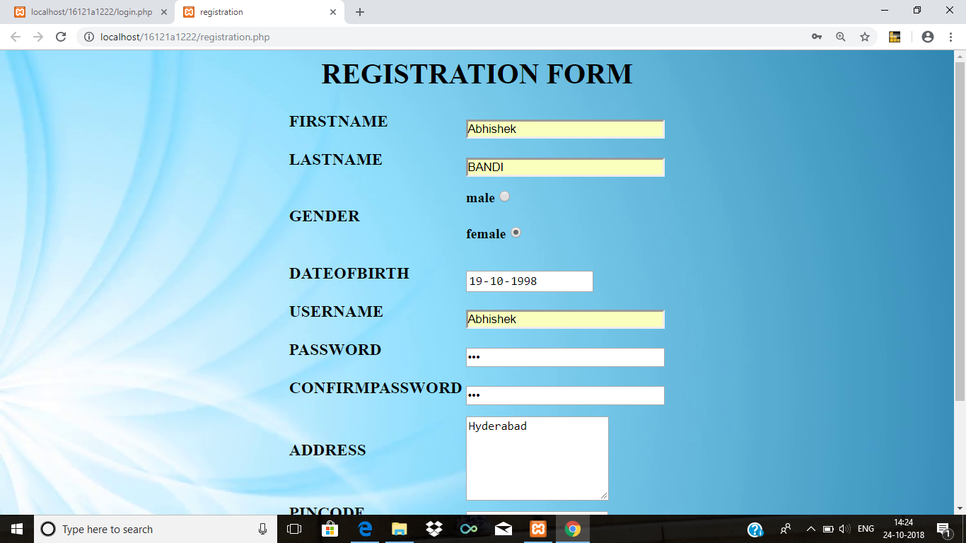

Fig : User Registration Page

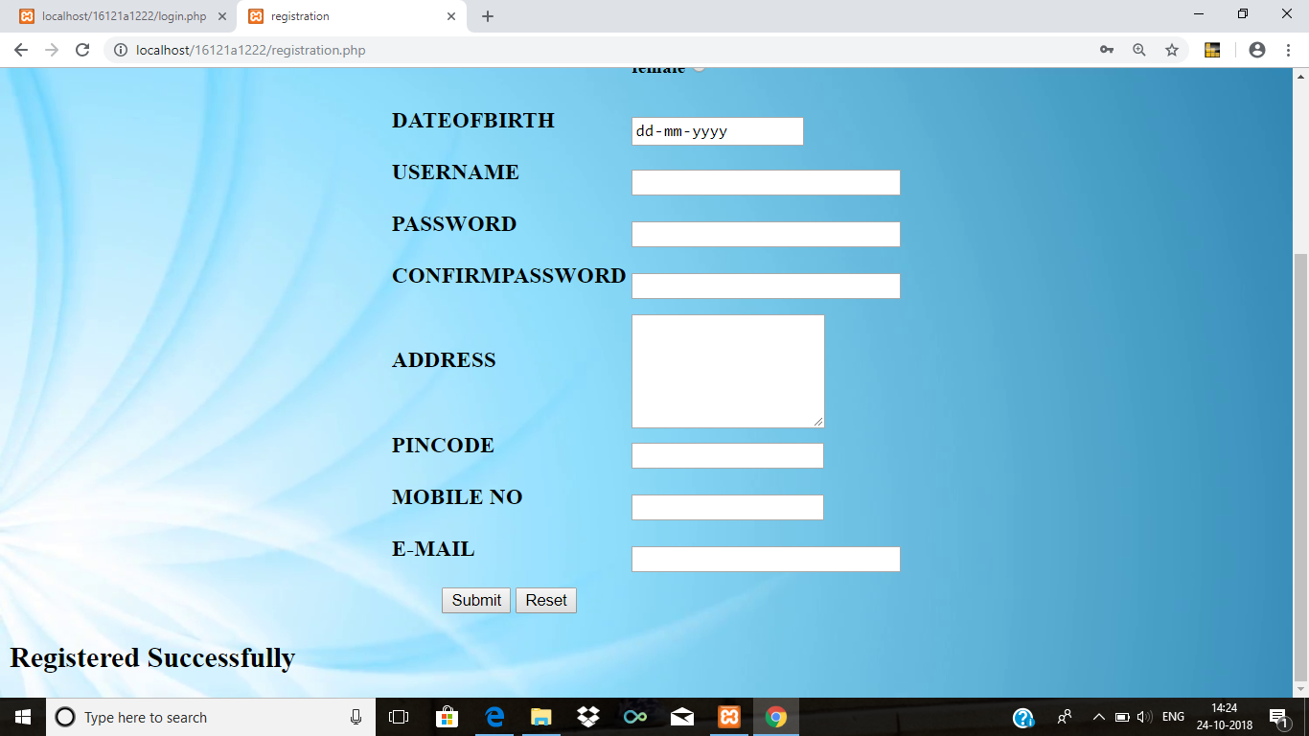

Fig : Registration Done Successfully

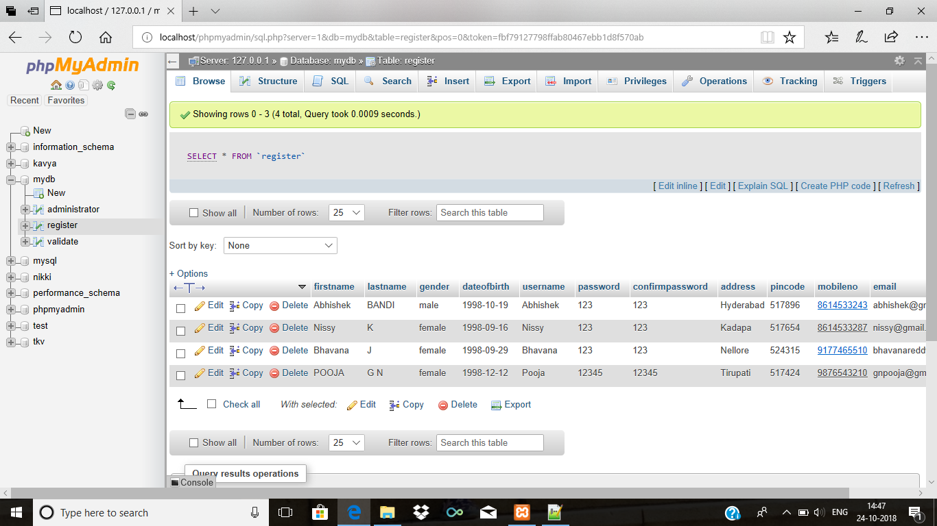

Fig : Stored Registration Details in Database

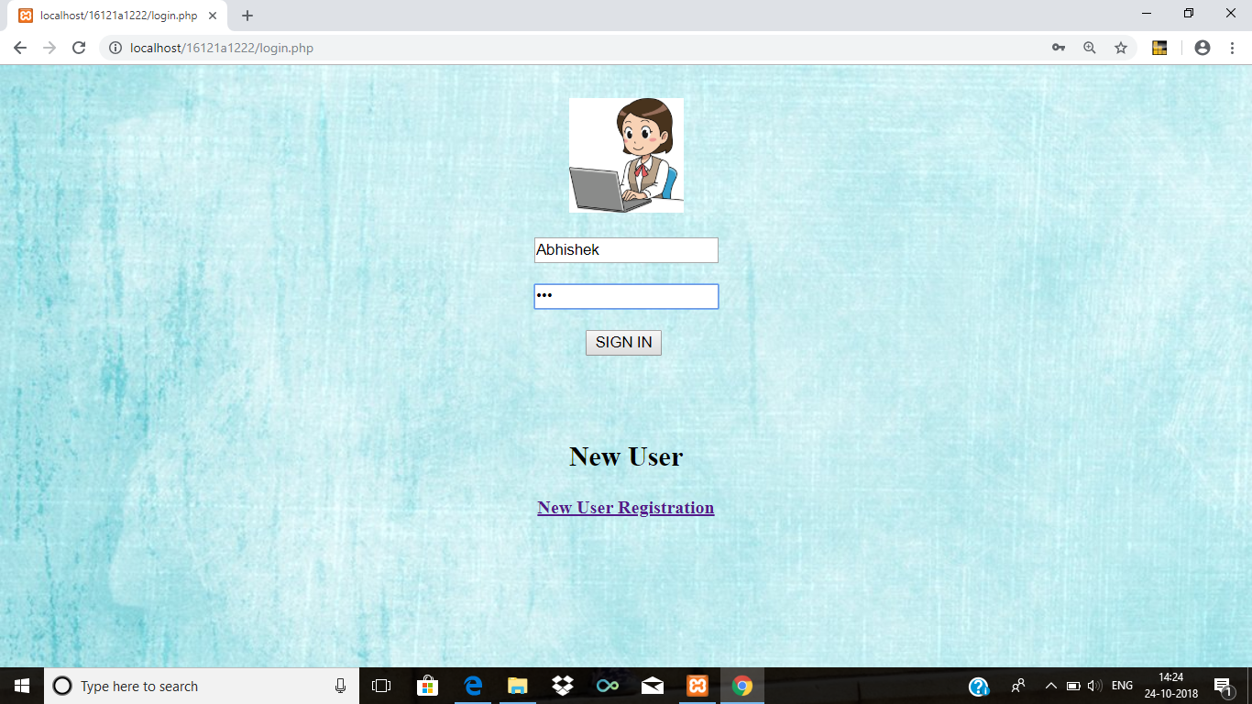

Fig : User Login Page



Fig : User Home Page



Fig : College Details

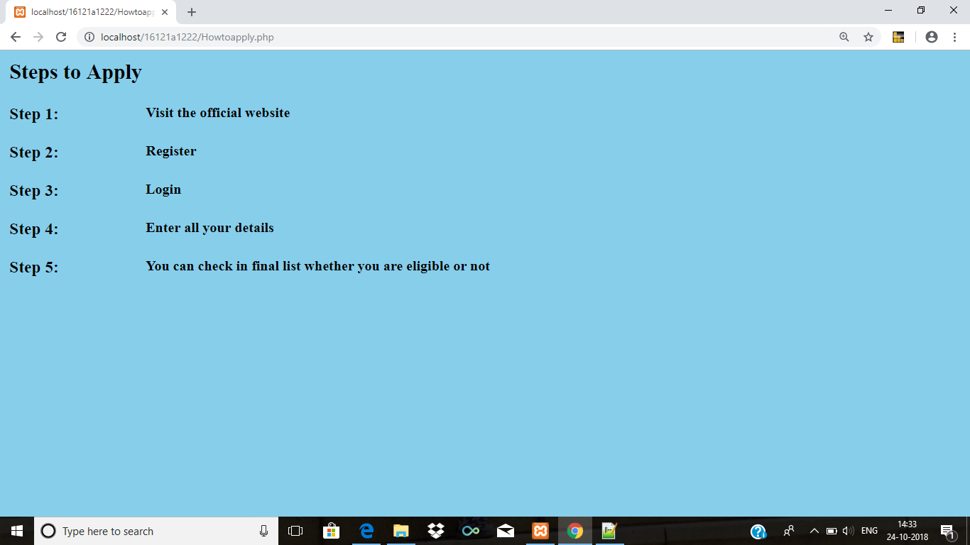

Fig : Procedure to Apply

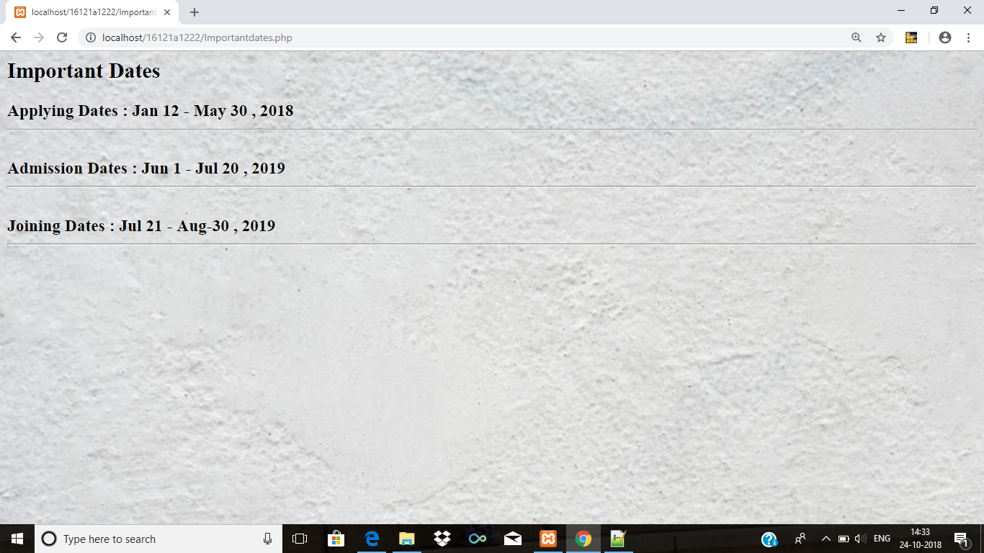

Fig : Important Dates

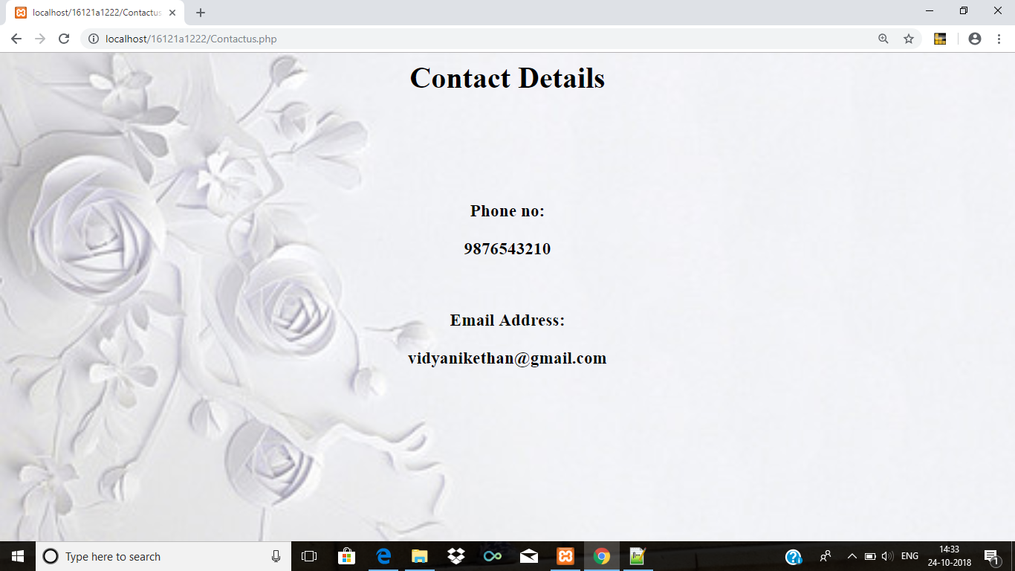

Fig : Contact Details

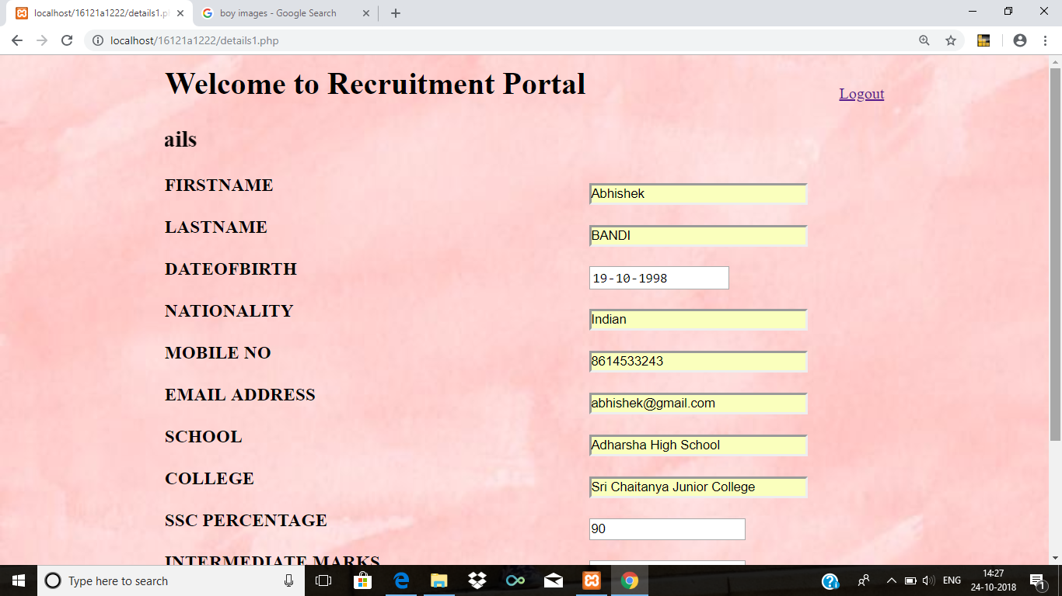

Fig : Student Details

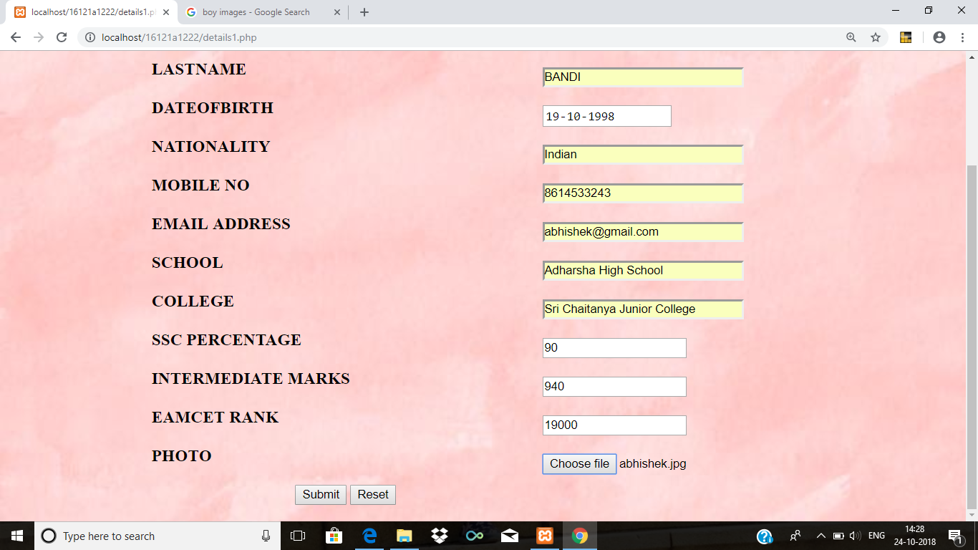

Fig : Student Details

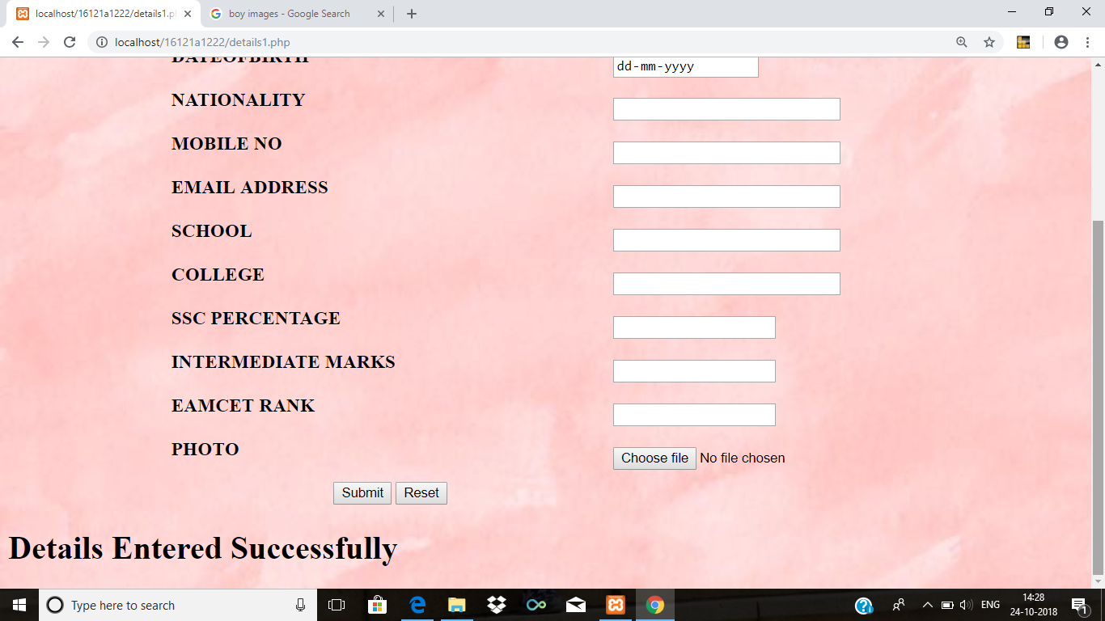

Fig : Applied Successfully

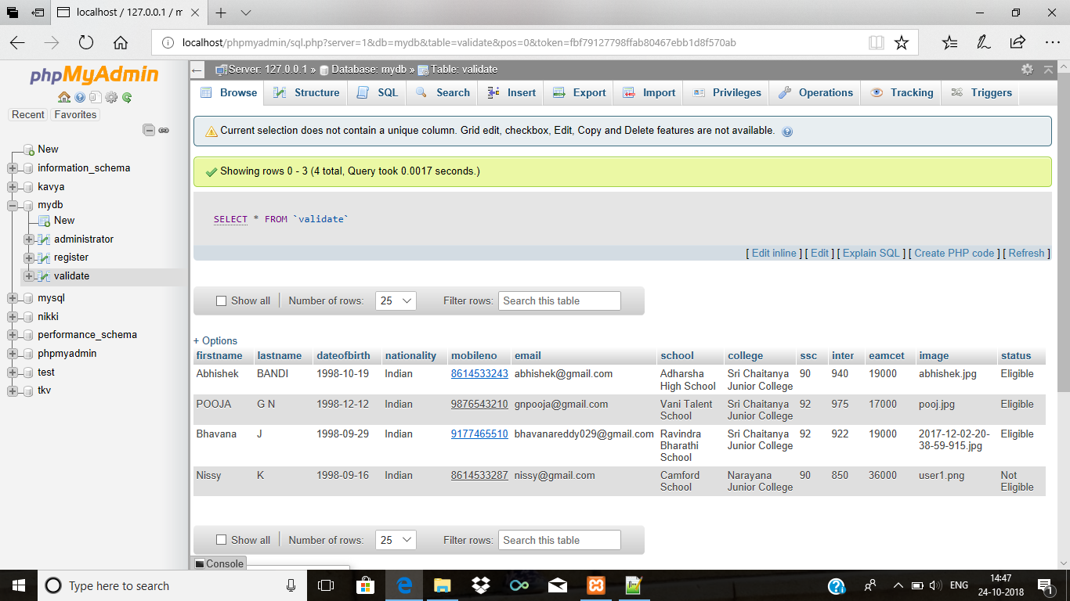

Fig : Student Details Stored in Database

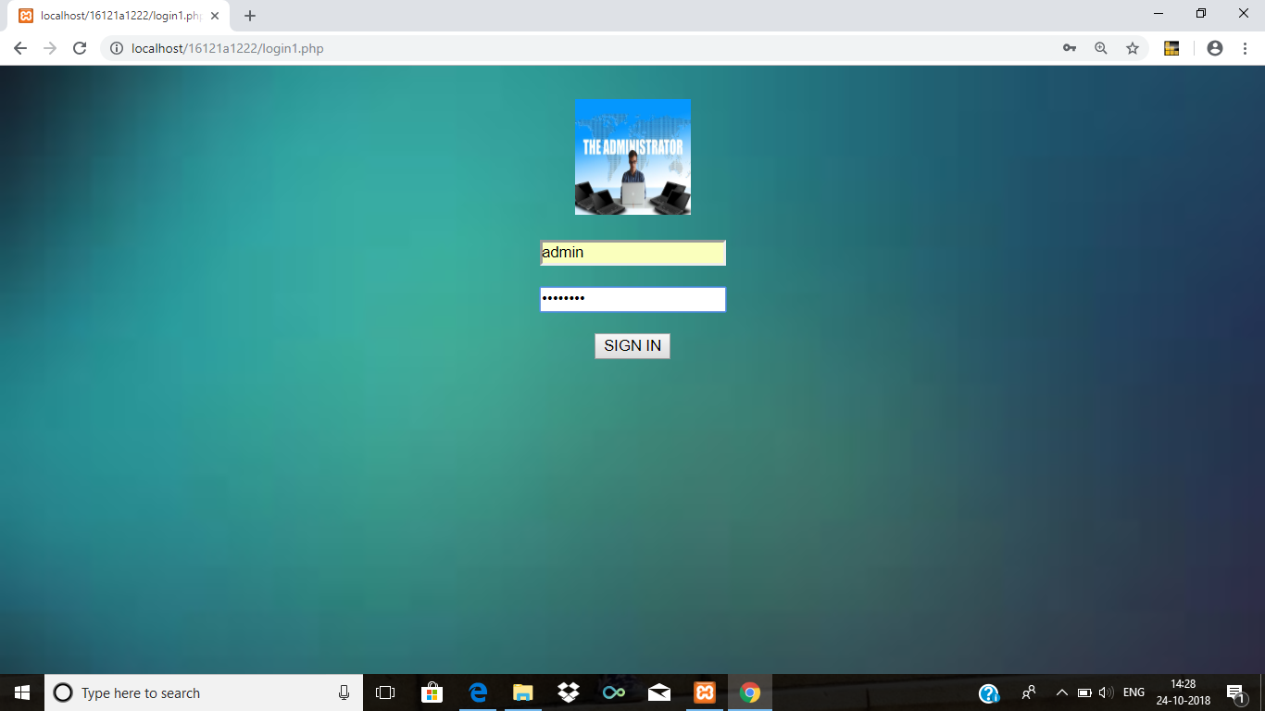

Fig : Administrator Login



Fig : Admin Home Page

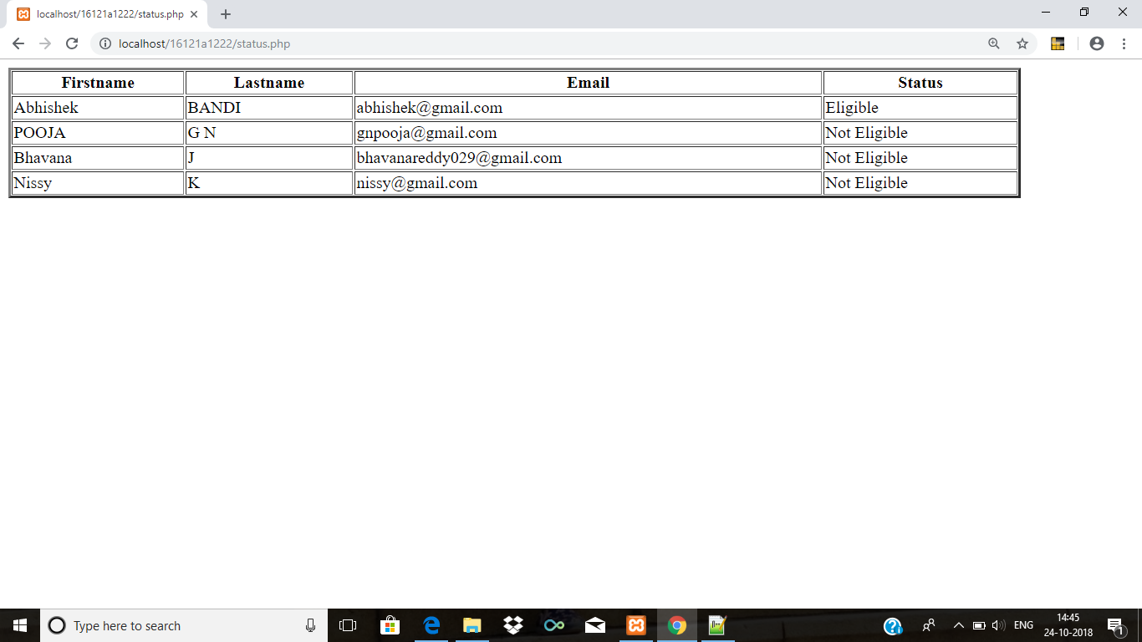

Fig : Students Status Before Finalization

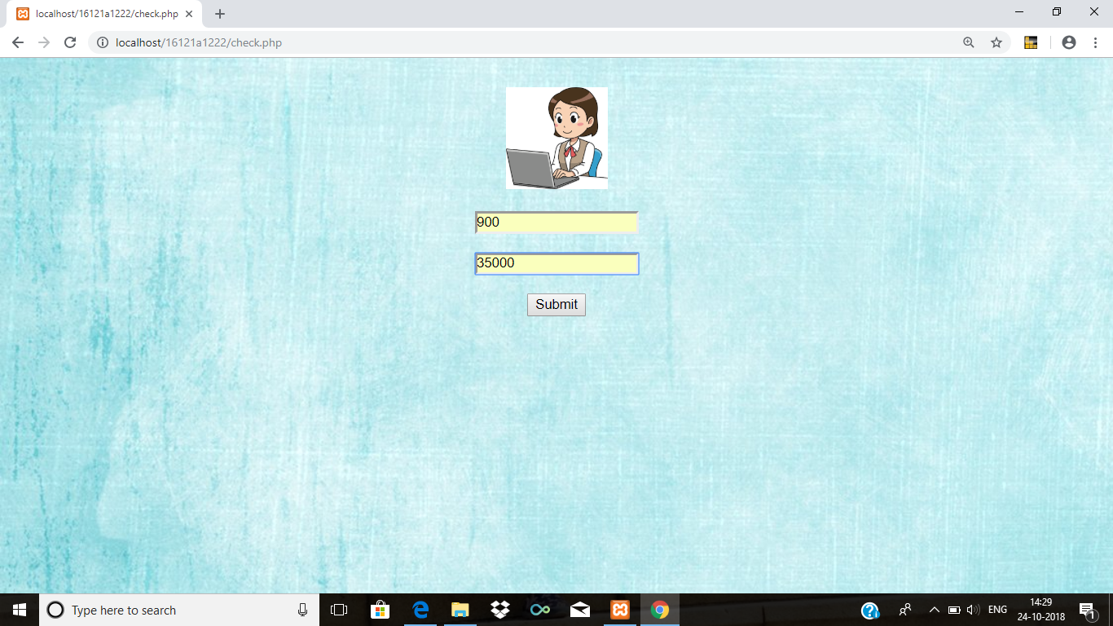

Fig : Admin Finalize Criteria

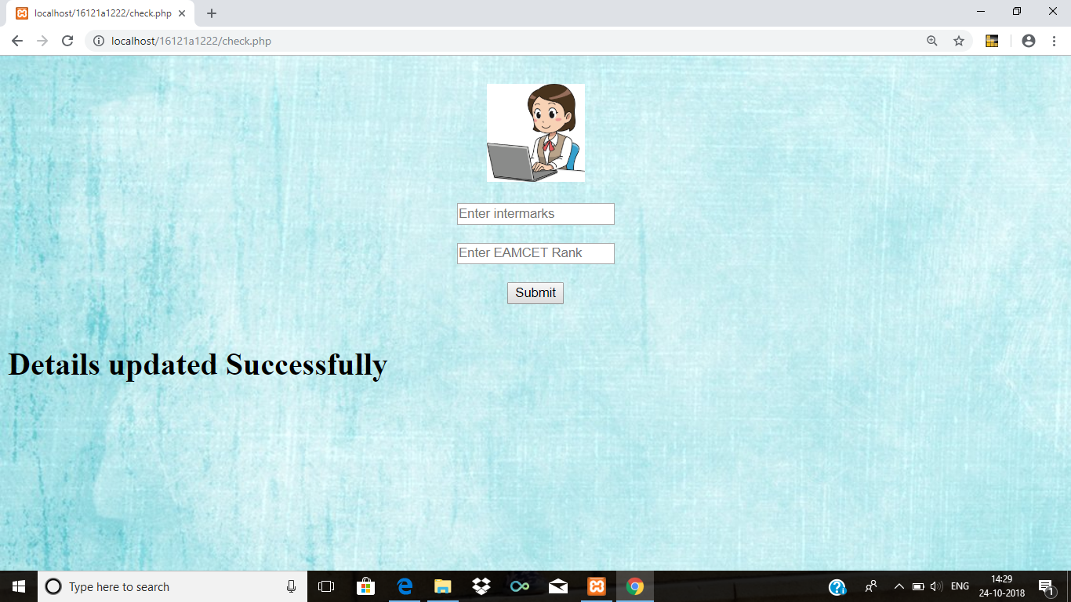

Fig : Criteria Updated Successfully

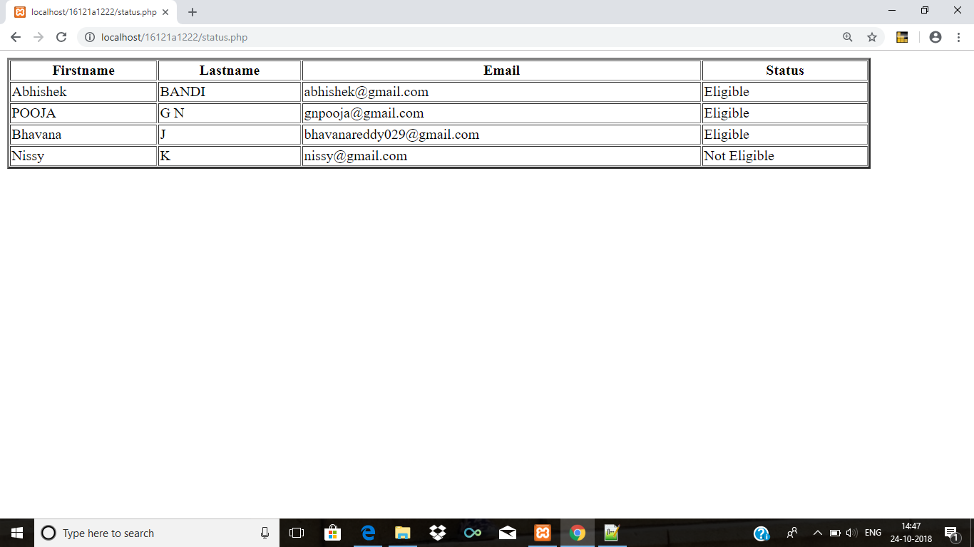

Fig : Students Status After Finalization